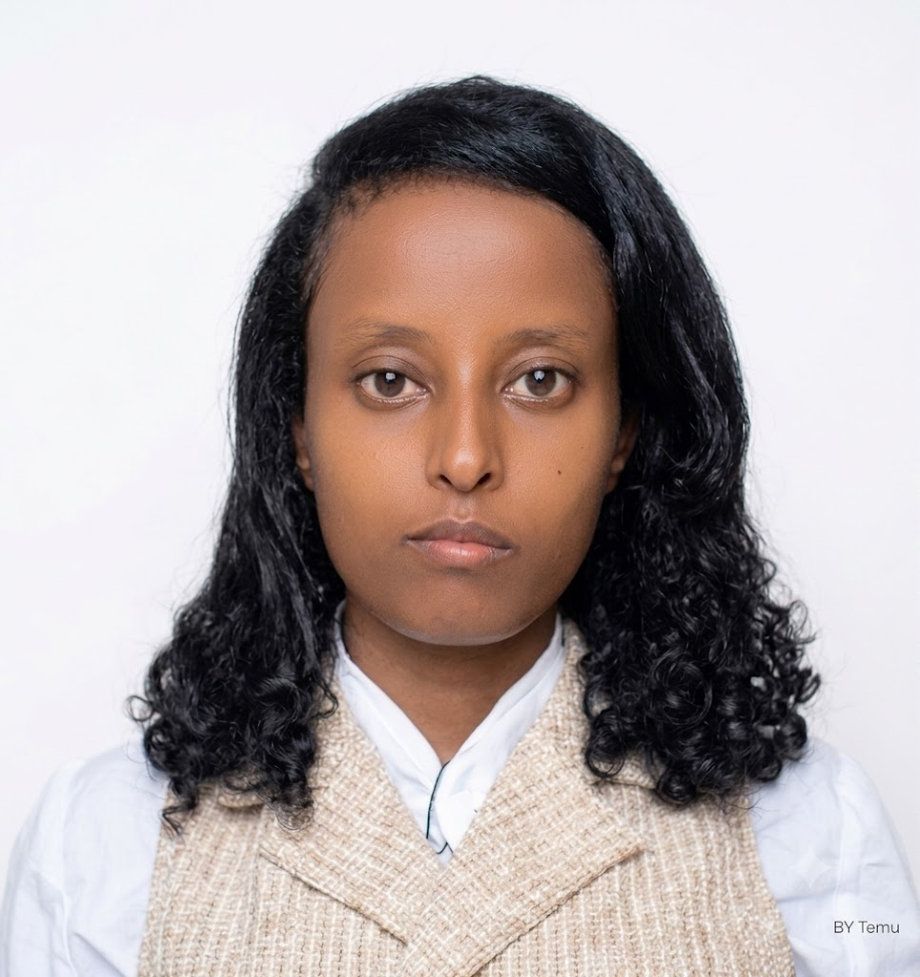 | Ms. Iliham Siraj BSc degree of Information System  Linkedin :  Portifolio :  Gmail :elihamsiraj369@gmail.com  Contact:+(251) 906323353  Location: Adama, Ethiopia

Addis Ababa, Ethiopia |elihamsiraj369@gmail.com | +(251) 906323353

Professional Summary
A BSc Information Systems student at Hawassa University with a GPA of 2.89 I have built a good understanding of areas like data analysis, system design, project management, and network administration through my studies. I’m interested in both the technical and organizational sides of IT, and I enjoy learning how technology can be used to solve real-world problems. I’m looking forward to starting my career and applying my skills in a practical environment.
Education
B.Sc. Information Systems,  Hawassa University-IOT Campus 2.89 GPA /4.00 | Apr 2023 -Jun 27 Hawassa,Ethiopia
Professional Experience
Peace Project leader, Hawassa University Jan 2025
● I won 1500 euro for peace project and i worked as poroject manager with my team in Hawasa city the project was prepared by British Council and European Union.
● I gave one week peace training for Tabor Highschool students.

Network and Hardware Engineer Intern, CBE IT Department Jun 2025 – Sep 2025 Adama

● Performed cable management, troubleshooting, and basic switch configuration and Hardware mentenance.
● Supported network setup and maintenance operations for new branch.
● Collaborated with senior engineers to ensure reliable and efficient network operations
Volunteer-Little Hearts Club , Hawassa University Jun 2023 – Nov 2025

● Organized weekly educational and recreational activities for street children.
● Led campus donation drives, distributing 100+ essential items to community partners.
● Strengthened leadership, coordination, and interpersonal skills through volunteer engagement.

SKILLS

Technical: Google Workspace, Microsoft Visio, Cisco Packet Tracer, Project Management Tools, Python, JavaScript, Git &GitHub.
Soft Skills: Communication, Team Collaboration, Problem-Solving, Risk Management, Project Planning, Leadership, Adaptability

CERTIFICATIONS
Data Analysis fundamental | UDACITY |  Artificial intelligence | UDACITY |  Peace Project leader |British Council and EUPE |  Gig Economy |Gebeya |  Awards | Jan 2026  Jan 2026  Dec 2024  Nov2025

Certification of Achievement, Hawassa University | Mar 2026
Certificate of Achievement, PCIC | Nov 2025
Certification of Participation, Little Heart Club | Nov 2024
LANGUAGES
English (Professional Working ) Amharic (Native)
References

Mr. Mekonnen Kassye Shiferaw
Head of information system Department
Hawasa University
mekonnenkassye19@gmail.com , +251919542977

Mr. Debrework Debebe
EUPE Project Coordinator
Hawasa University
debreworkdebebe.hu.edu.et

